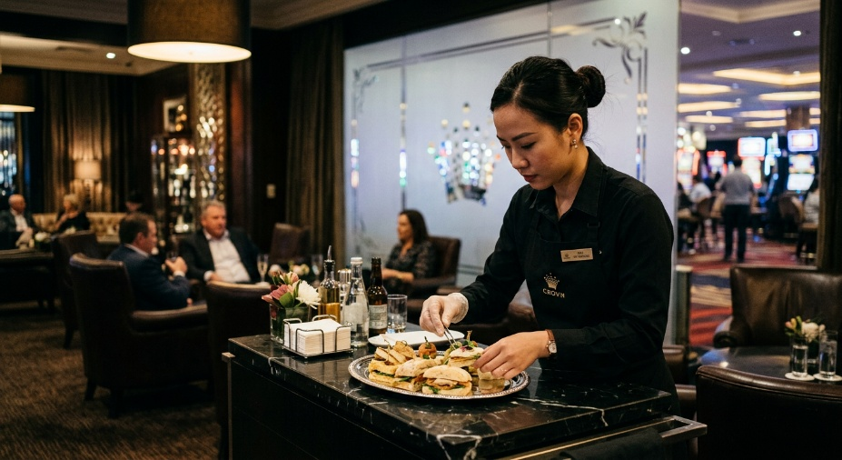
Learner #4: Chloe Nguyen

About Me: | Chloe is a 27-year-old VIP service professional at The Grand Casino & Exchange in Adelaide, where she has worked in the Diamond Lounge for the past eighteen months. She moved to Adelaide from Brisbane in mid-2024 and transferred across to the Adelaide casino under an internal transfer arrangement after five years with the same employer in Queensland. She is widely regarded by floor management and regulars as the standout attendant on the team, with an unblemished service record and a long list of senior staff who have come up through her informal mentoring. Chloe currently lives in shared accommodation in the inner city; her listed address has changed twice in the last six months and her contact phone number was recently updated.
Professional and Learning Experience: | Chloe holds a Certificate III in Hospitality (SIT30622, completed with Credit, 2019). Her current credentials include RSA, RCG/RSG (recertified 2023), Food Safety Supervisor (SITXFSA005 and SITXFSA006, renewed 2024), Mental Health First Aid (2022), and a Statement of Attainment for Conflict Resolution in Service Environments. She is also up to date on internal AML/CTF awareness training.  Her practical experience includes five years of front-line VIP service in a regulated gaming environment (her first three-and-a-half years at the Brisbane venue, the last eighteen months at the Adelaide property), two years prior as a barista and all-rounder at a high-volume CBD cafe, and ongoing informal mentoring of new lounge hires. She has formally shadowed and signed off four junior staff through their 90-day inductions over the last twelve months, and her most recent performance appraisal rated her 5 out of 5 across every Key Result Area. She is currently working toward TAE40122.
Career/Training Goals: | Chloe wants to transition into a formal Training and Assessment role within the casino's HR/Training department, where she has been earmarked as a Subject Matter Expert. Her medium-term goal is to lead the RSG Awareness workshop for the Spring Racing Carnival intake and to author a formal SOP manual for the VIP Pantry. She is open to further qualifications and has expressed interest in eventually delivering responsible gambling and AML/CTF content across multiple venues.
Working Style and Preferences: | Chloe's instructional style is measured, calm, and scenario-based. She uses role-play before live shifts to build new staff confidence (her appraisal specifically notes the example of preparing a new hire, Sophie, for an intoxicated guest interaction), and she breaks complex protocols like the iOrder billing system into manageable steps. She is comfortable with on-the-spot constructive correction and is described by her manager as “patient” and “non-critical.” Chloe handles conflict de-escalation with notable composure, including two significant patron incidents resolved without needing to escalate to security, and her incident reporting (such as the recent 6-hour problem-gambling welfare check) is detailed, reflective, and policy-aligned.  Chloe's availability for study is heavily constrained by her shift roster, which is predominantly evening and overnight (typically finishing between 02:00 and 04:00). She prefers to be contacted by email rather than phone, and she has asked previously that any course communications not be sent to a workplace address. She tends to keep her personal life private and prefers learning environments where she is not asked to share personal details with the wider group. She has declined to sign the standard student talent release form during enrolment and has specifically requested not to appear in any marketing material, testimonials, photography, or video produced by the RTO; she was polite but firm about this and noted that the same request is on file with her employer.  She is technically fluent and uses her phone for almost all study and admin; she has mentioned that she does not currently have a regular home internet connection and tends to study from cafes, the casino's staff lounge, or her phone's hotspot.
Additional Information: | Chloe enjoys baking and has previously mentioned a quiet interest in calligraphy and bookbinding. She does not drive at present and uses public transport or rideshare to and from shifts. She has asked the casino HR team to flag her file as “do not disclose roster details to third parties,” which is a matter of personal privacy that she has not elaborated on. She has also mentioned that she does not have any family or long-term friends in Adelaide and that the move from Brisbane was “a clean start.” Her preferred learning approach is one-on-one or small-group sessions held outside her work hours, and she has mentioned that face-to-face workshops on-site at the casino are easier for her to attend than off-site sessions during the day.

